# Shifa Tameer-e-Millat University

# IMG_256

**LAB MANUAL**

**Computer Communication and Networks**

**(SE3771)**

**6thEdition**

**Department Of Computing**

1

**Lab Manual for Computer Networks Week-2**

(LAB-1)

(Introduction to CISCO Packet Tracer)

**Outline**

|  |  |  |  |
| --- | --- | --- | --- |
| **Sr.** | **Title** | **Week** | **Page No.** |
| 1. | LAB-1 Introduction to CISCO Packet Tracer | 2 | 4 |
| 2. | LAB-2 Introduction to client server model | 3 | 28 |
| 3. | LAB-3 Configuration of Routers and switches using command line interface | 4 | 41 |
| 4. | LAB-4 Routers with multiple networks and static routing | 5 | 50 |
| 5. | LAB-5 IP routing with serial cable | 6 | 60 |
| 6. | LAB-6 Dynamic routing using RIP | 7 | 69 |
| 7. | LAB-7 Dynamic routing using EIGRP | 8 | 80 |
| 8. | Mid Term Examination | 9 | Nil |
| 9. | LAB-8 link state routing OSPF multi area | 10 | 95 |
| 10. | LAB-9 Redistributing routing protocols | 11 | 107 |
| 11. | LAB-10 Configuration of Virtual LAN’s | 12 | 126 |
| 12. | LAB-11 Configuration of inter Virtual LANs | 13 | 137 |
| 15. | Final Term Examination | 16 | Nil |

Contents

1. [Introduction 6](#_bookmark0)
   1. [Network 6](#_bookmark0)
   2. [Network Topology 7](#_bookmark1)
   3. [Types of network topologies 7](#_bookmark1)
   4. [Mesh topology 7](#_bookmark1)
   5. [Star Topology 7](#_bookmark1)
   6. [Bus Topology 8](#_bookmark2)
   7. [Ring Topologies 8](#_bookmark2)
   8. [Tree Topologies 8](#_bookmark2)
2. [Tools required 9](#_bookmark3)
3. [Objective of the Experiment 9](#_bookmark3)
4. [Installation Cisco Packet Tracer 7.0 in Windows 7,8,10 – 32/64 Bit 9](#_bookmark4)
5. [Walk-through Tasks 14](#_bookmark5)
   1. [Task 1 14](#_bookmark5)
   2. [Task 2 25](#_bookmark6)
6. [Practice Tasks 28](#_bookmark7)
   1. [Task 1 28](#_bookmark7)

[6.1. Task 2 29](#_bookmark8)

[6.1. Task 3 29](#_bookmark8)

[6.1. Task 4 29](#_bookmark8)

**Lab 1: Introduction of CISCO Packet Tracer**

# Introduction:

Packet Tracer (PT) is a **protocol simulator** developed by Cisco Systems, designed to visualize and simulate network protocols and behavior in both **Real-Time (RT)** and **Simulation Mode (SM)**. PT is a versatile tool, used extensively in network training to model various network components and protocols across different layers.

**Layer 2 Protocols**:

* **Ethernet (ETH)**: A foundational technology for wired local area networks.
* **Point-to-Point Protocol (PPP)**: A protocol used to establish a direct connection between two networking nodes.

**Layer 3 Protocols**:

* **Internet Protocol (IP)**: The primary protocol for routing data across networks.
* **Internet Control Message Protocol (ICMP)**: Used for network diagnostics and error reporting.
* **Address Resolution Protocol (ARP)**: Resolves IP addresses to MAC addresses in a local network.

**Layer 4 Protocols**:

* **Transmission Control Protocol (TCP)**: Ensures reliable data transmission between network devices.
* **User Datagram Protocol (UDP)**: A connectionless protocol allowing faster, but less reliable, data transmission.

Packet Tracer also supports various **Routing Protocols (RP)**, enabling the simulation of complex routing behavior. While PT is a powerful network modeling tool, it serves as a supplement rather than a replacement for **hands-on experience** with actual Cisco routers and switches. By modeling network scenarios, PT helps students and network engineers alike develop practical Cisco technology skills, providing a valuable training environment for **Network Certifications (NC)**.

Network engineers often utilize Packet Tracer to simulate complex configurations before deploying them on physical hardware. However, it is essential to understand that PT labs enhance your skills in network simulation rather than teaching networking fundamentals directly.

# Network:

A **computer network**, also known as a **data network**, is a digital telecommunications network that allows nodes (devices like computers, servers, and other networked equipment) to share resources. In these networks, devices communicate and exchange data through connections known as **data links** that exist between nodes.

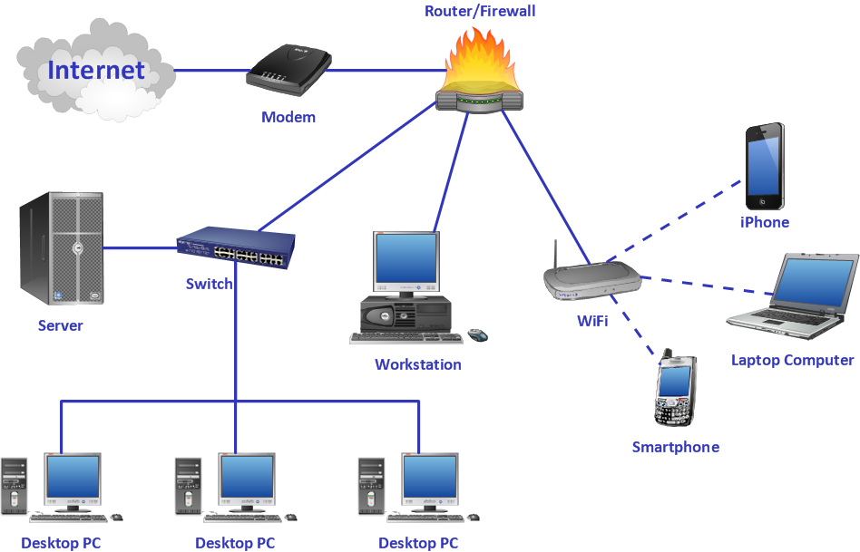

**Figure .1 : Computer Network**

# Network Topology:

**Network topology** refers to the arrangement and interconnection of various elements (like links and nodes) within a communication network. It describes both the **physical layout** (actual connections between nodes) and the **logical structure** (data flow patterns) of a network. Understanding network topology is essential, as it impacts the performance, efficiency, and scalability of the network.

# Types of network topologies:

The five common types of network topologies are:

* **Bus Topology**
* **Ring Topology**
* **Star Topology**
* **Mesh Topology**
* **Tree Topology**

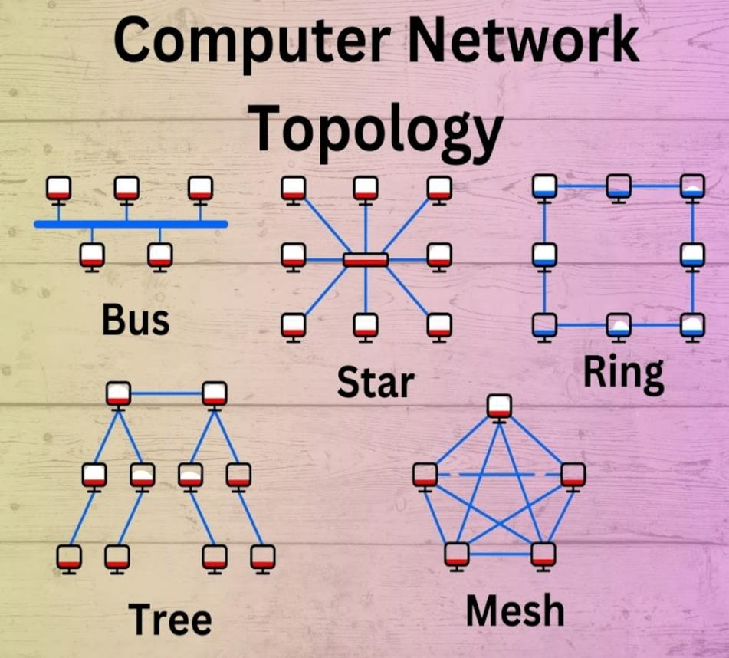

**Figure .2: Computer Network Topology**

# Bus topology:

In a **bus topology**, all nodes share a single communication line or "bus." Data is transmitted across the bus, and each node listens for data addressed to it.

* **Advantages**:
  + Simple and inexpensive to implement, requiring less cable than other topologies.
  + Easy to extend by adding more devices along the bus line.
* **Disadvantages**:
  + Network performance decreases as more devices are added, leading to potential congestion.
  + A failure in the main bus line can bring down the entire network.

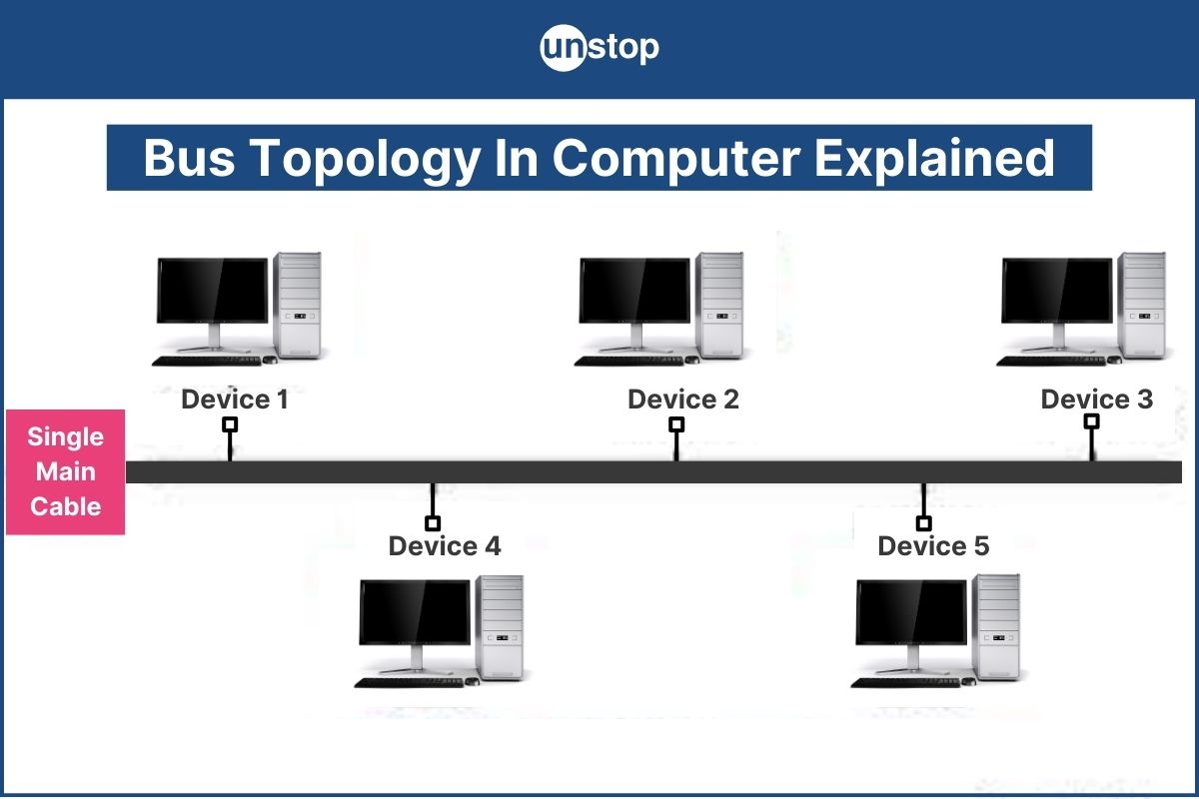

**Figure .3: Bus Topology**

# Ring topology:

A **ring topology** connects each node to exactly two other nodes, forming a closed-loop or "ring." Data travels in one direction around the ring until it reaches its destination.

**Advantages**:

* + Efficient at handling high traffic since data flows in one direction.
  + Easy to install and reconfigure by adding or removing nodes.

**Disadvantages**:

* + Vulnerable to network failure if any single connection breaks, as it disrupts the entire network.
  + Troubleshooting can be challenging, as identifying a break in the ring can be difficult.

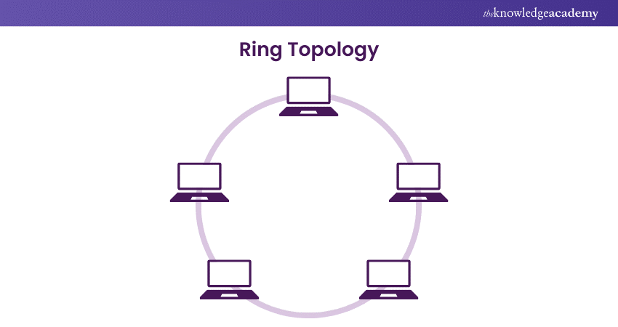

**Figure. 4: Ring Topology**

1. **Star Topology:**  
   In a **star topology**, all nodes are connected to a central hub or switch. Data passes through this central hub to reach other nodes.

* **Advantages**:
  + Easy to install and manage, with a central point (hub or switch) that simplifies troubleshooting.
  + Failure of a single device does not affect the network; only the central hub's failure impacts the network.
* **Disadvantages**:
  + If the central hub or switch fails, the entire network is affected.
  + Requires more cable than bus or ring topologies, increasing initial setup costs.



**Figure .5: Star Topology**

1. **Mesh Topology:**  
   A **mesh topology** provides multiple pathways between nodes, with each node connected to every other node. This creates high redundancy, ensuring data can always find an alternate route if one path fails.

* ****Advantages**:**
  + Highly reliable due to multiple redundant paths, ideal for critical applications where downtime is unacceptable.
  + Data can travel more directly between nodes, reducing latency.
* ****Disadvantages**:**
  + Complex and costly due to the large number of connections and cables required.
  + Difficult to maintain and troubleshoot as the network scales.



**Figure .6: Mesh Topology**

1. **Tree Topology**  
   A **tree topology** combines elements of bus and star topologies in a hierarchical structure, with nodes arranged in levels. It typically has a central "root" node, branching downwards.

* **Advantages**:
  + 1. Scalable, as nodes can be added easily without major changes to the overall layout.
    2. Organized and structured, making it ideal for larger networks where control over sub-networks is required.
* **Disadvantages**:
  + 1. Failure of the main root node can disrupt the entire network.
    2. As the network grows, management becomes more complex and may require more robust hardware.

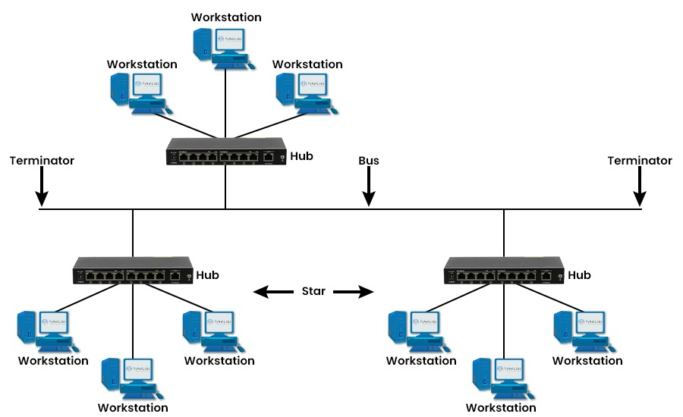

**Figure .7: Tree Topology**

Each topology has unique benefits and limitations, making it suitable for different network types, sizes, and requirements. Selecting the right topology involves considering factors such as network size, reliability needs, and ease of maintenance.

# Tools required:

* CISCO Packet tracer

# Objective of the Experiment:

After completing this Lab student should able to:

* Install of Cisco Packet Tracer.
* To Have understanding of use of CISCO Packet Tracer.
* To Have knowledge about Each and Every Component used in this Software as Related to course.
* Have that much knowledge, to make topologies and further working on this easily.
* Make and construct Mesh topology on cisco packet tracer.
* Make and construct Star topology on cisco packet tracer.
* Make and construct Bus topology on cisco packet tracer.
* Make and construct Ring topology on cisco packet tracer.
* Make and construct Tree topology on cisco packet tracer.

###### Installation Cisco Packet Tracer ****Windows Desktop Version 8.2.2 English****

**[64 Bit Download](https://legacy.netacad.com/portal/resources/file/bb132b3b-117e-419d-8de5-bbdfe37667d8)**

**[32 Bit Download](https://legacy.netacad.com/portal/resources/file/8b450333-c90a-480a-b168-2b3cb9addbd2)**

**How to Install Cisco Packet Tracer on Windows?**

# Packet Tracer is computer software that is designed with the purpose of making network simulations to understand the networking and cyber security concepts in an easy way. It is built by Cisco Corporation and is available for free for different operating systems like macOS, Windows, Linux, etc. It is easy to easy with a simple interface.

# **Installing Packet Tracer on Windows**

# **Follow the below steps to install Packet Tracer on Windows:**

# **Step 1:** Visit the official website of Netacad using any web browser.

# **OR**

You have to download CISCO Packet Tracer from the give link:

[Cisco Packet Tracer](https://jitl.jp/packet-tracer)



**Figure .8: Official Website of Netacad**

**Step 2:** Press the login button and select log In option.

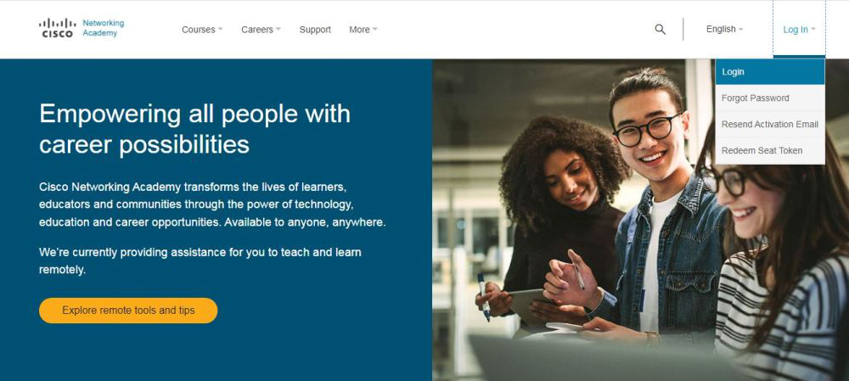

**Figure .9: log In option.**

**Step 3:** Next screen will appear, click on the sign-up option.

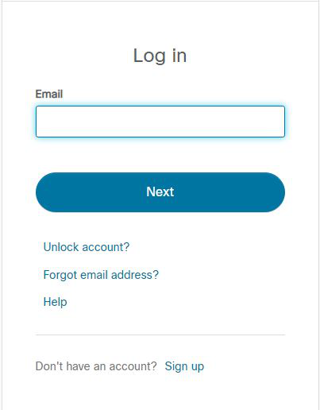

**Figure .10: Sign-up-option**

**Step 4:** Next screen will appear and will ask for email and password and other simple details, fill them and click on Register.

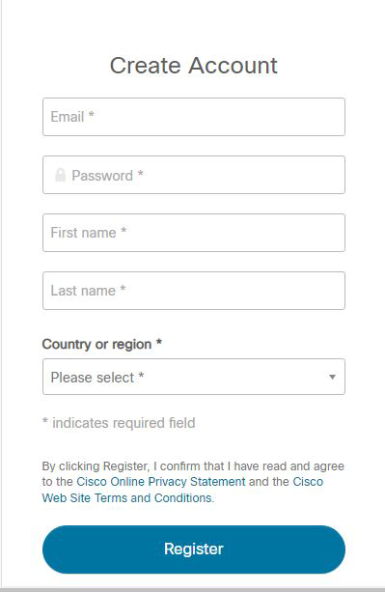

**Figure .11: click on Register.**

**Step 5:** Now the login screen appears again so fill in the Email id.

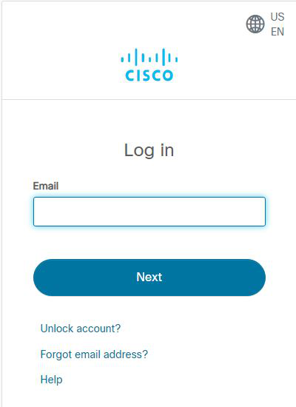

**Figure .12: Email id.**

**Step 6:** On the next screen enter the password and press the Login button.

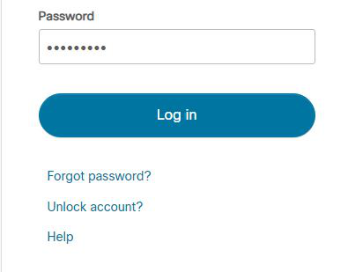

**Figure .13: Enter the password and press the Login button.**

**Step 7:** Dashboard will initialize, now click on Resources and choose Download Packet Tracer Option.

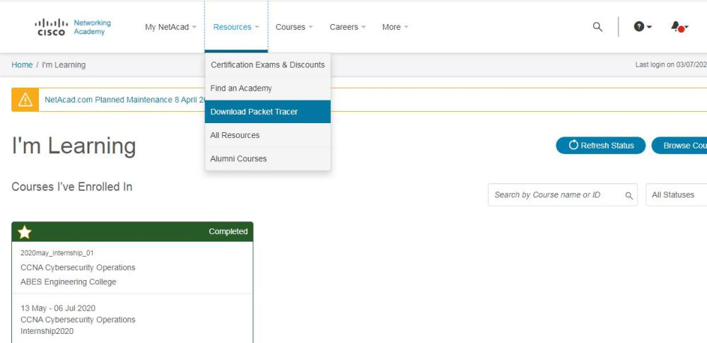

**Figure .14: Download Packet Tracer Option.**

**Step 8:** On the next web page choose the operating system to download the packet tracer. Downloading will start automatically.

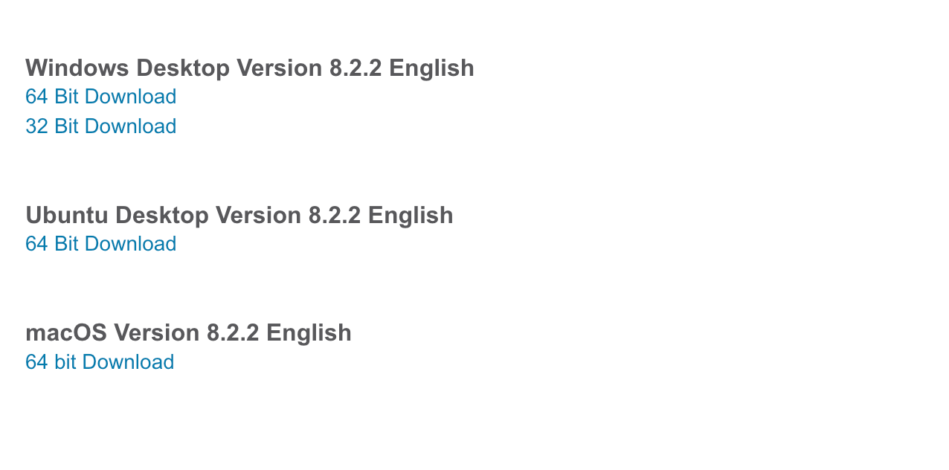

**Figure .15: choose the operating system to download the packet tracer.**

**Step 9:** Check for the executable file in your system and run it.

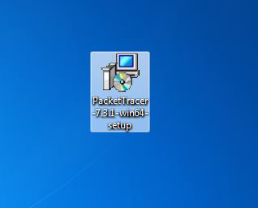

**Figure . 16: Check for the executable file in your system and run it.**

**Step 10:** Next screen is of License Agreement so Click on I accept the license.

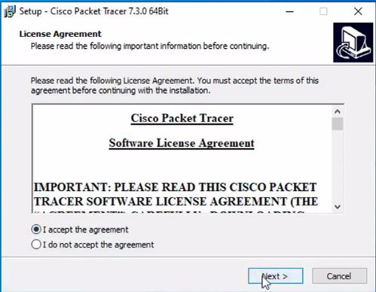

**Figure .17: License Agreement so Click on I accept the license.**

**Step 11:** Choose the installing location which has sufficient space.

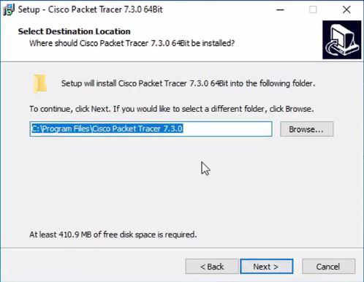

**Figure .18: Choose the installing location which has sufficient space.**

**Step 12:** Select the start menu folder and click the Next button.

**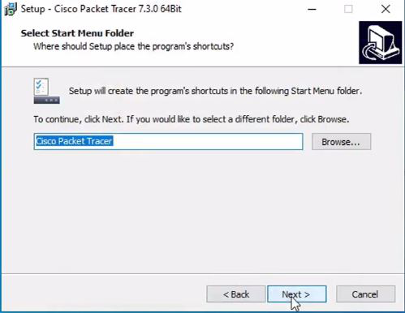**

**Figure .19: Select the start menu folder and click the Next button**.

**Step 13:** Check the box for creating a desktop icon and click on the Next button.

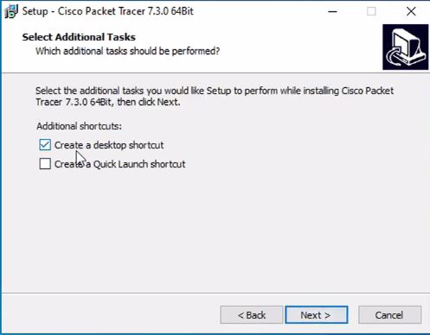

**Figure .20: Creating a desktop icon and click on the Next button**

**Step 14:** Now packet tracer is ready to install so click on the Install button.

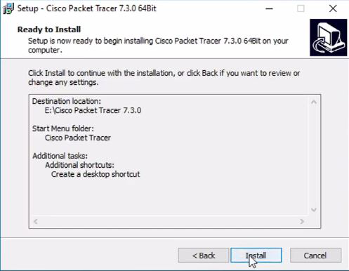

**Figure .21: Now packet tracer is ready to install so click on the Install button.**

**Step 15:** The installation process will start and will hardly take a minute.

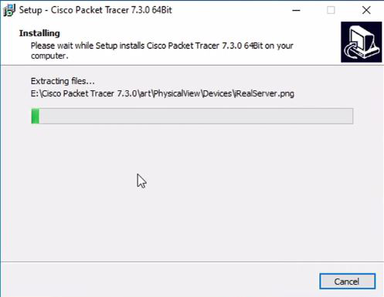

**Figure .22: The installation process will start and will hardly take a minute.**

**Step 16:** Click on the Finish button to complete the installation.

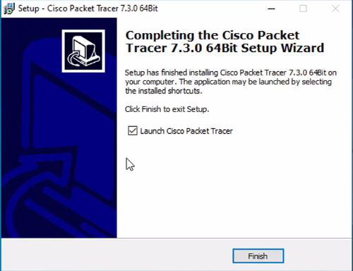

**Figure .23: Finish button to complete the installation.**

**Step 17:** An icon is created on the desktop so run it.

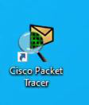

**Figure .24: An icon is created on the desktop so run it.**

**Step 18:** Interface is initialized and the software is ready to use.

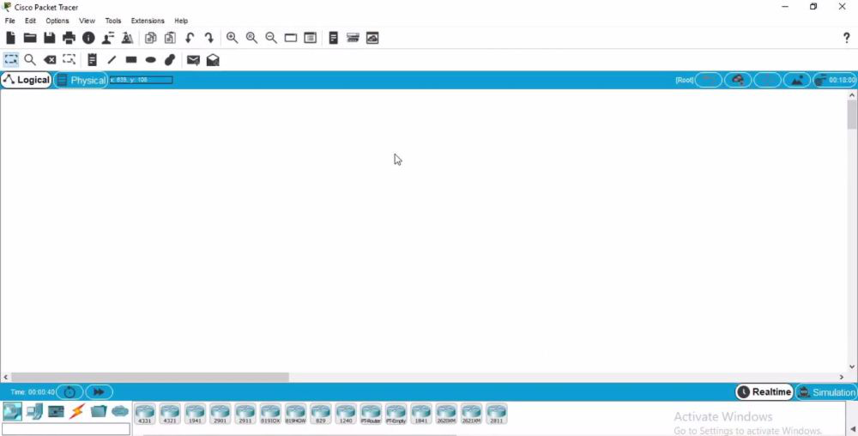

**Figure .25: Interface is initialized and the software is ready to use.**

**Congratulations you have successfully installed packet tracer on your Windows System.**

As we selected Launch option, Packet tracer is automatically launched. It should look like

below.

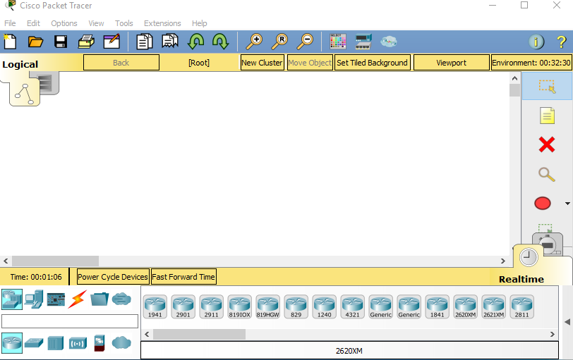

**Figure . 26: packet tracer Console.**

# Walk-through Tasks:

# 5.1 Task 1:

**Start Packet Tracer**



**Figure . 27: Packet tracer console**

We will begin building our network topology by selecting devices and the media in which to connect them. Several types of devices and network connections can be used. For this lab we will keep it simple by using End Devices, Switches, Hubs, and Connections. Single click on each group of devices and connections to display the various choices.

When we select a device in the left panel, in the right panel we see all the listed devices of that type.

**Click on end devices**

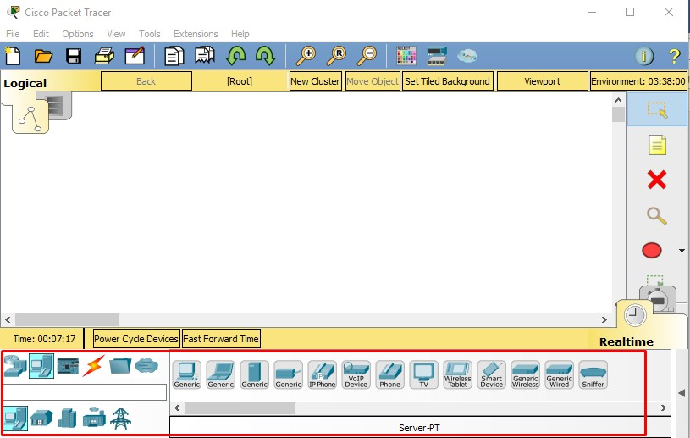

**Figure . 28: Showing end devices on Packet tracer**

**Single click on the Generic host.**

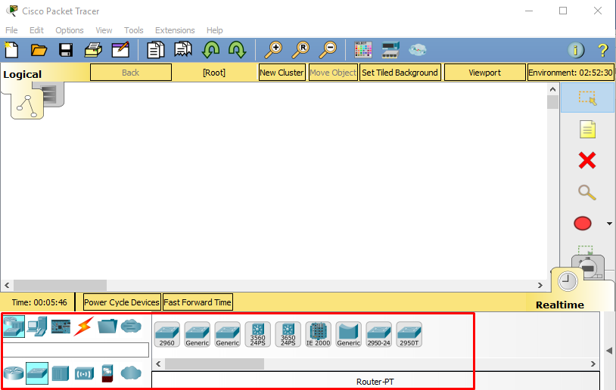

**Figure .29: showing generic hosts**

Move the cursor into topology area. You will notice it turns into a plus “+” sign. Single click in the topology area and it copies the device.

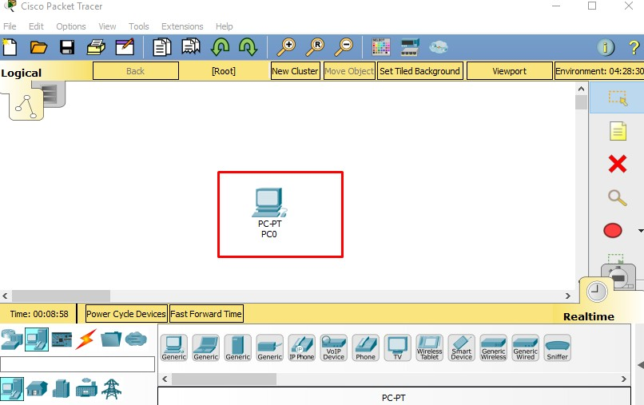

**Figure . 30: Selection of generic computer**

Add three more hosts.

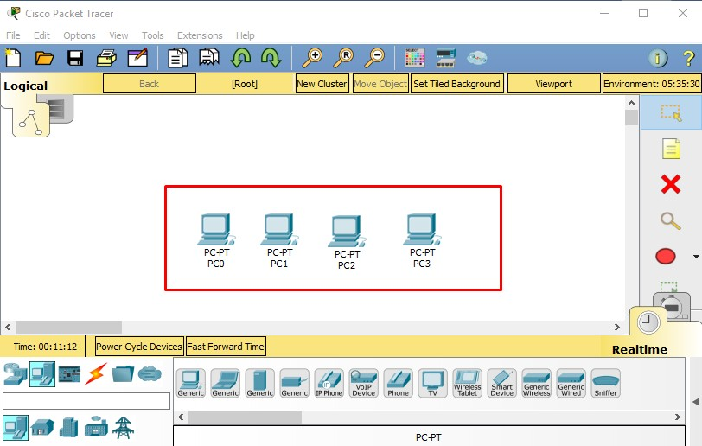

**Figure .31: selection of further three generic hosts**

**Select a hub, by clicking once on Hubs and once on a Generic hub.**

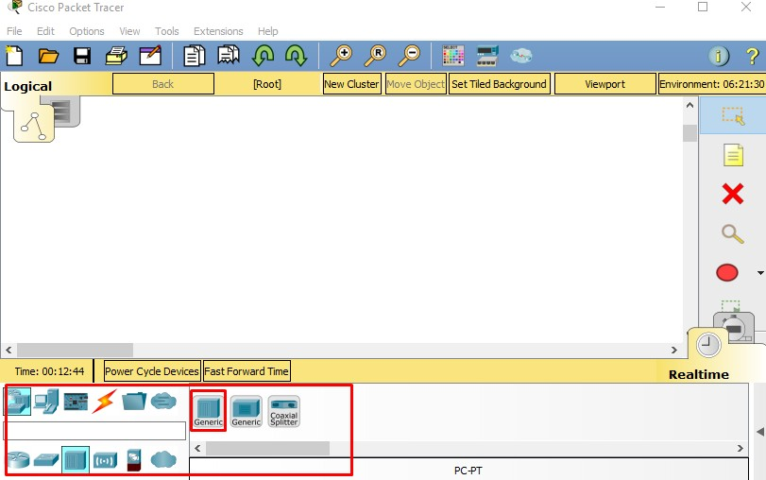

**Figure .32: selection of Hub**

**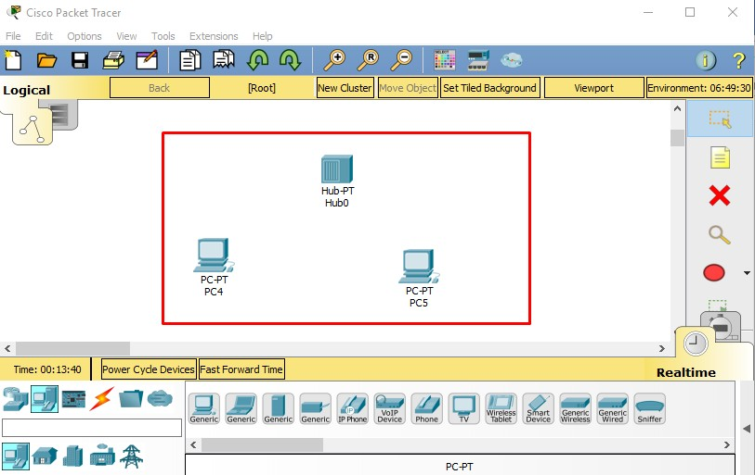Add the hub by moving the plus sign “+” below PC0 and PC1 and click once.**

**Figure .33: Adding PC'S with**

**Hubs Connect PC0 to Hub0 by first choosing Connections.**

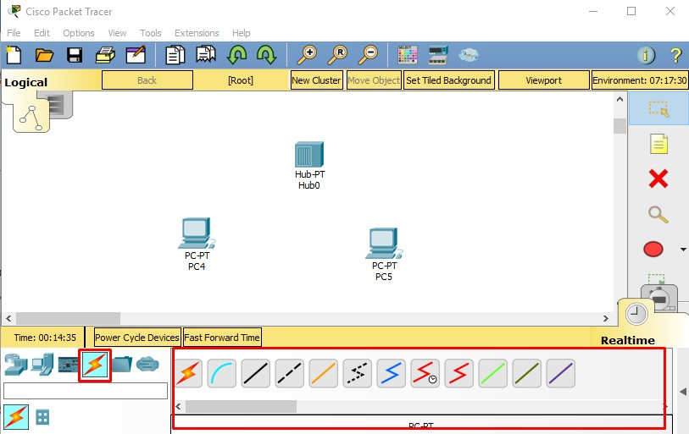

**Figure .34: Showing how to select connections**

**Click once on the Copper Straight-through cable.**

**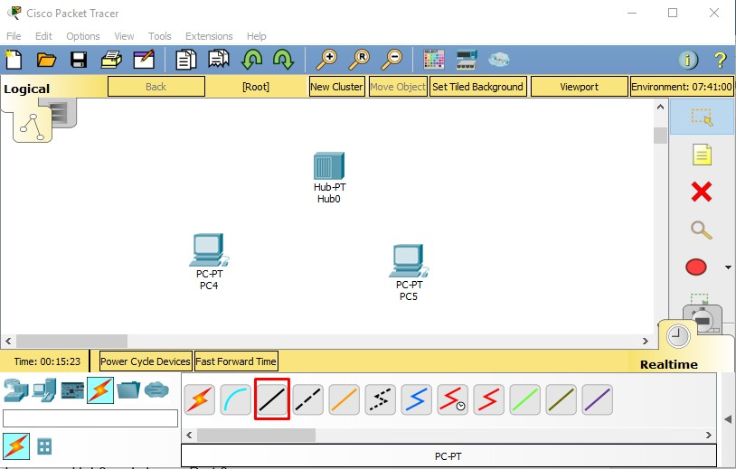**

**Figure .35: Selection of copper wire**

**Perform the following steps to connect PC0 to Hub0:**

1. Click once on PC0
2. Choose Fast Ethernet
3. Drag the cursor to Hub0
4. Click once on Hub0 and choose Port 0
5. Notice the green link lights on both the PC0 Ethernet NIC and the Hub0 Port 0 showing that the link is active.

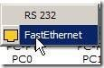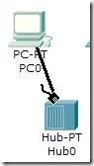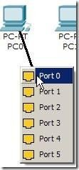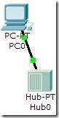

**Figure .36: Wired Connection**

**Repeat the steps above for PC1 connecting it to Port 1 on Hub0. (The actual hub port you choose does not matter.**

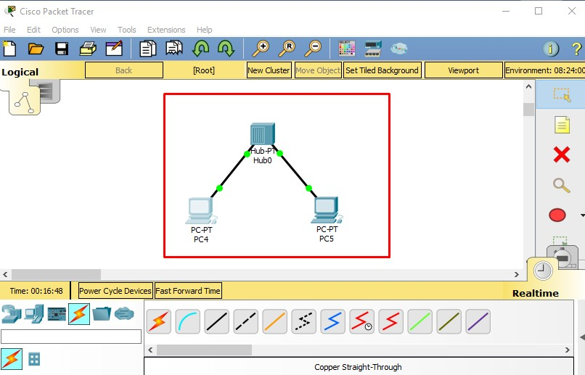

**Figure .37: Connecting through copper wire**

**Select a switch, by clicking once on Switches and once on a 2950-24 switch.**

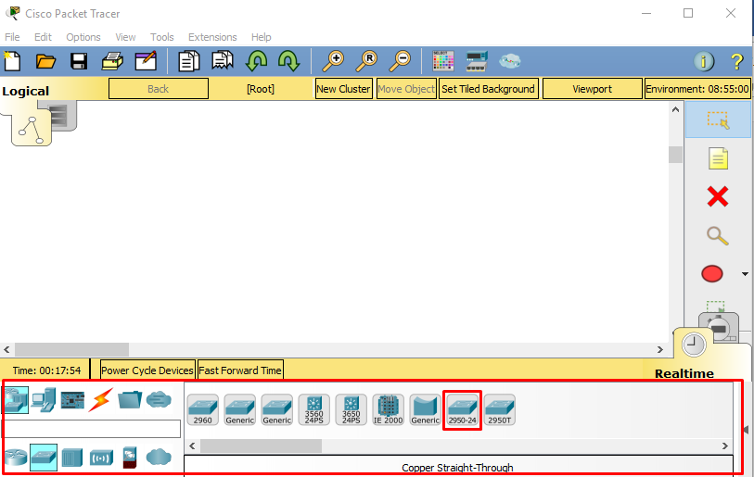

**Figure .38: Selection of switch**

**Add the switch by moving the plus sign “+” below PC2 and PC3 and click once.**

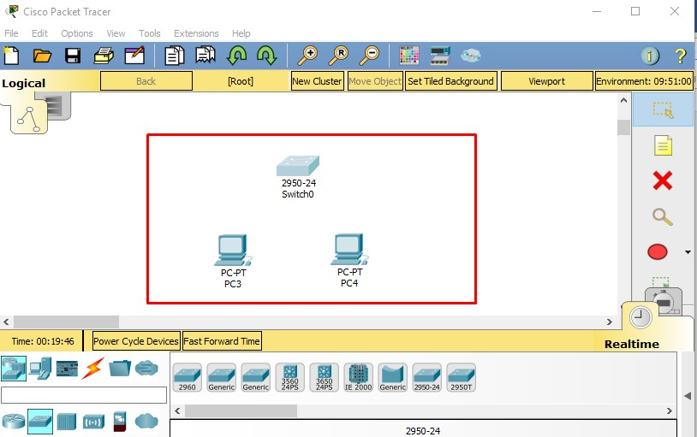

**Figure .39: Selecting two PC'S and Switch**

**Connect PC3 to switch0 by first choosing Connections. Click once on the Copper Straight- through cable.**

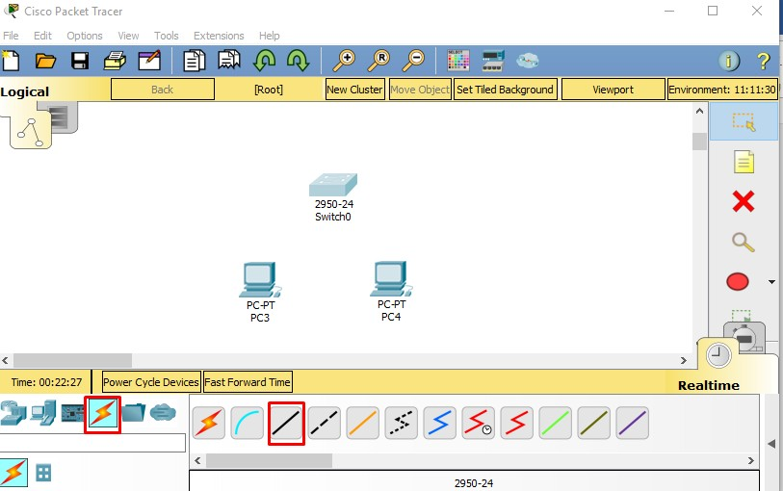

**Figure .40: Selecting copper wire**

**Perform the following steps to connect PC2 to Switch0:**

* 1. Click once on PC3
  2. Choose Fast Ethernet
  3. Drag the cursor to Switch0
  4. Click once on Switch0 and choose Fast Ethernet0/1
  5. Notice the green link lights on PC4 Ethernet Network Interface Card (NIC) and amber light Switch0 FastEthernet0/1 port. The switch port is temporarily not forwarding frames, while it goes through the stages for the Spanning Tree Protocol (STP) process.
  6. After a about 30 seconds the amber light will change to green indicating that the port has entered the forwarding stage. Frames can now have forwarded out the switch port.

|  |  |  |  |  |  |
| --- | --- | --- | --- | --- | --- |
| 1 | 2 | 3 | 4 | 5 | 6 |

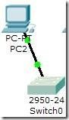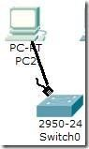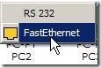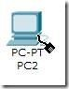

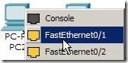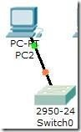

**Figure .41: Connecting Pc's with switch through copper wire**

**Repeat the steps above for PC3 connecting it to Port 3 on Switch0 on port FastEtherent0/2. (The actual switch port you choose does not matter.)**

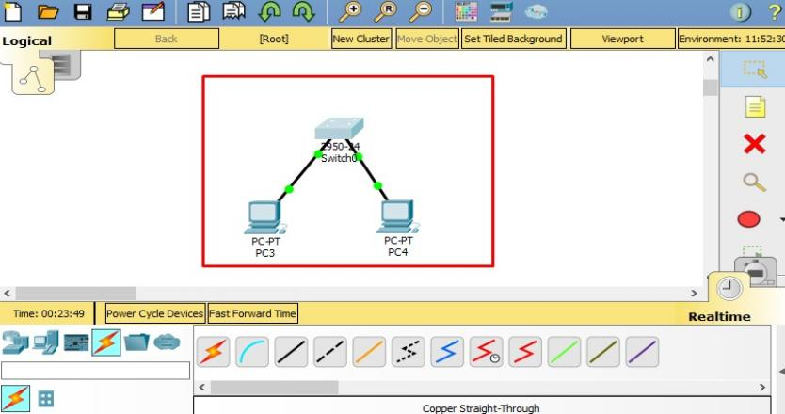

**Figure .42: Connecting Pc's with switch through copper wire**

**Move the cursor over the link light to view the port number. Fa means FastEthernet, 100 Mbps Ethernet.**

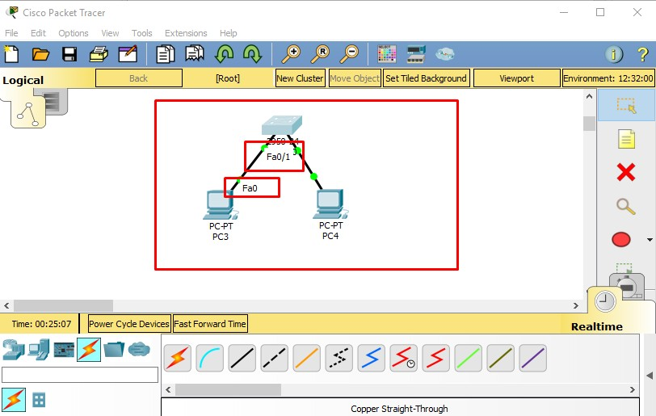

**Figure . 43: Showing Interfaces**

**After you successfully create the topology like here Be sure you are in Realtime mode.**

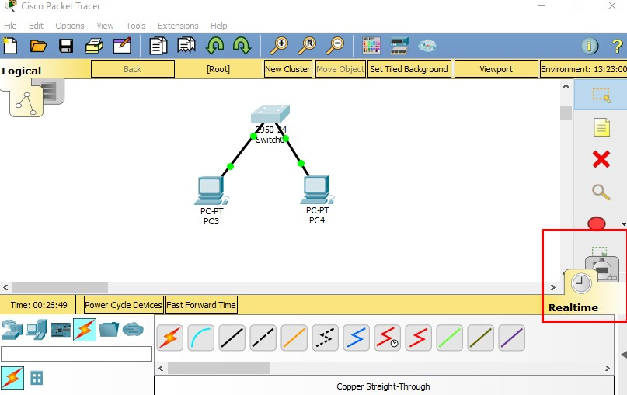

**Figure . 44: Showing Real time**

**Select the Add Simple Protocol Data Unit (PDU) tool used to ping devices.**

**Assigning IP addresses:**

After connecting devices with switch, now for checking them you have to assign IP address to end devices, which is our case is PC0 and PC1 or either one you have, how you will assign IP address follow the following steps:

* + 1. Click on PC0 once.
    2. Select Desktop tap when terminal open on above tab.
    3. You will have a multiple tab in front of you, select IP configuration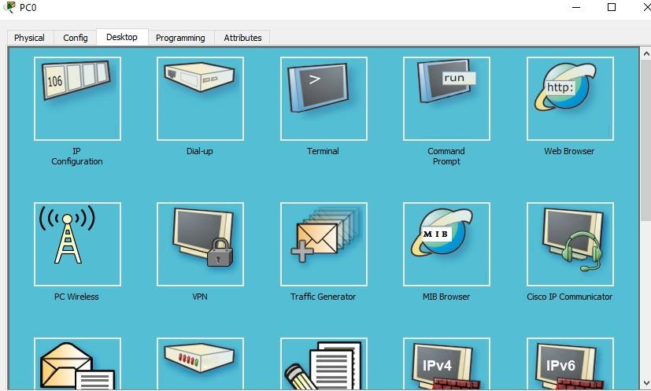
    4. Enter valid IP addresses, subnet mask and default gateway.

**Figure . 45: Showing Desktop of PC**

**Select IP configuration, the first tab then,**

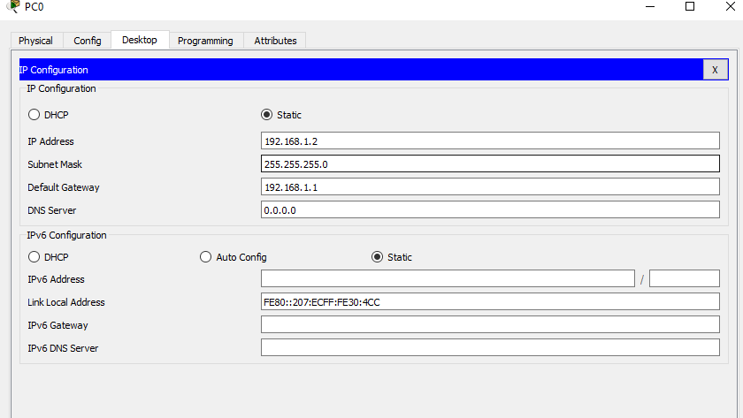

**Figure .46: IP configuration**

**And close the window by filling up with the valid IP addresses, subnet mask and default gateway.**

**Do same for the next PC1 and enter the valid IP addresses, subnet mask and default gateway.**

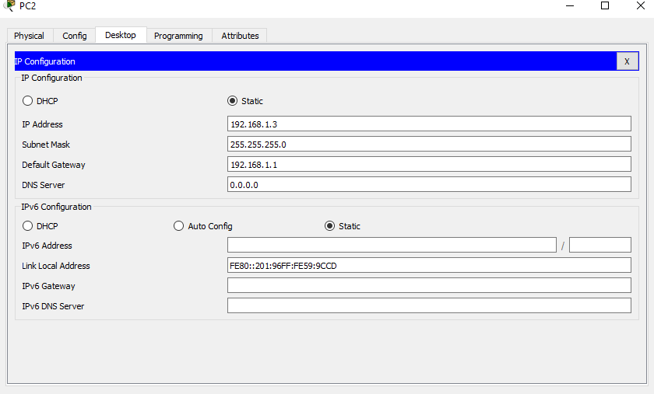

**Figure .47: IP configuration of other PC**

**Results:**

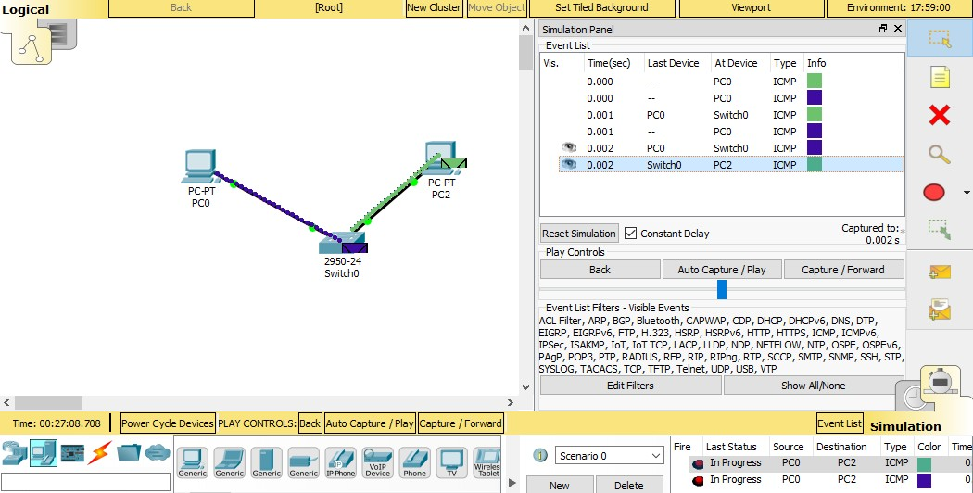

**Figure .48: Results showing packet sending**

**Click once on PC0, then once on PC3.**

**The PDU Last Status should show as Successful.**

# Task

Create a bus topology by using four switches and four laptops assign them proper IP addresses, subnet masks and default gateways of the network.

For creating this topology follow these instructions:

1. Open cisco packet tracer.
2. Add four switches and four laptops.
3. Connect all switches with each other by using copper cross-over cable.
4. Connect laptops with switch by using copper straight through cable.
5. 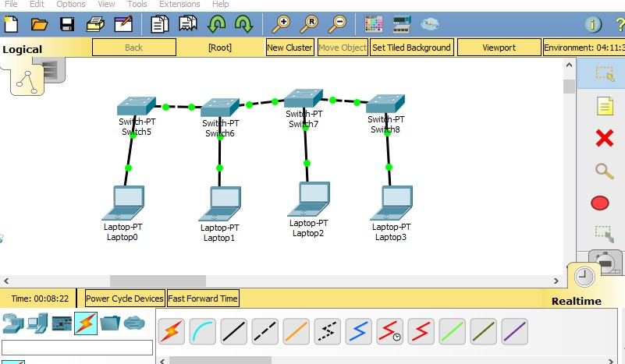Until this stage you should have topology like this.

**Figure 49: showing bus topology in cisco packet tracer**

1. **Now after this, click on laptop and go in desktop tab, which will look like:**

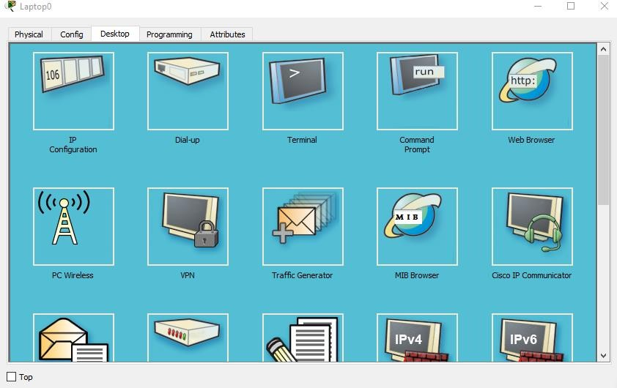

**Figure .50: Figure showing Desktop of the laptop**

1. **Click on IP configuration application on left corner of the terminal to configure IP address and subnet masks of the laptops, that will look like:**

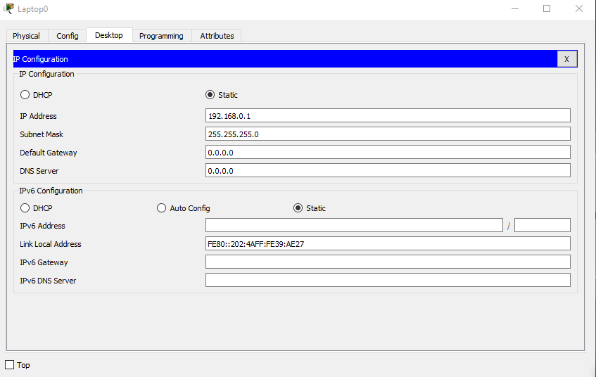

**Figure .51: Showing Ip address configurations**

1. Give IP address in IP address column which is 192.168.0.1.
2. Give subnet mask in IP address column which is 255.255.255.0.
3. Repeat the same for all laptop by incrementing each IP address to one like in second laptop you have to give IP address, which is 192.168.0.2 and subnet mask will remain the same.
4. Here all the configuration has been done now, you have to check whether a PDU from one laptop can be sent to another laptop or not.
5. **Make sure that you will be in Realtime mode.**

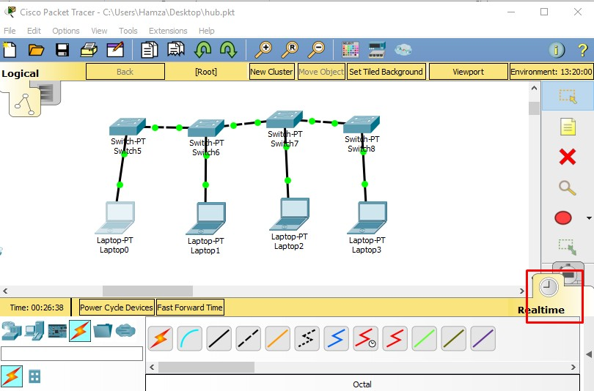

**Figure .52: showing cisco packet tracer in** **Realtime mode.**

1. **Now click on the PDU and add PDU from laptop0 to laptop3**.

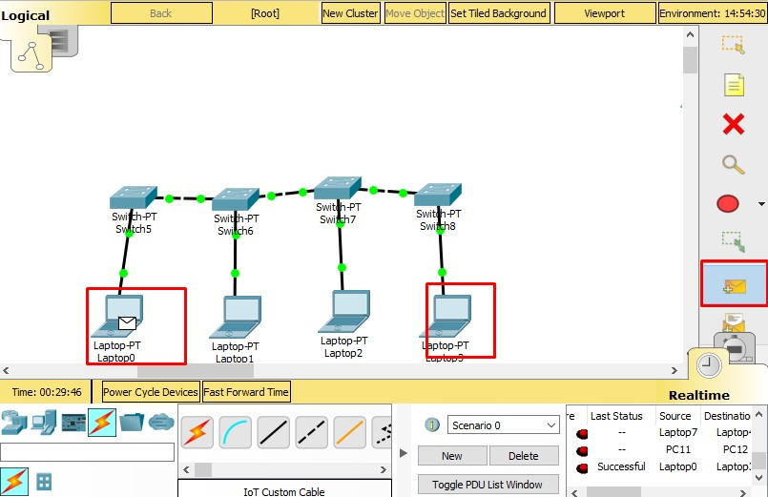

**Figure .53: Sending PDU from laptop0 to laptop3**

1. **After sending PDU from laptop0 to laptop3, you can see the status of your PDU that rather its successful or not, which is depicting at the right lower corner of the terminal.**

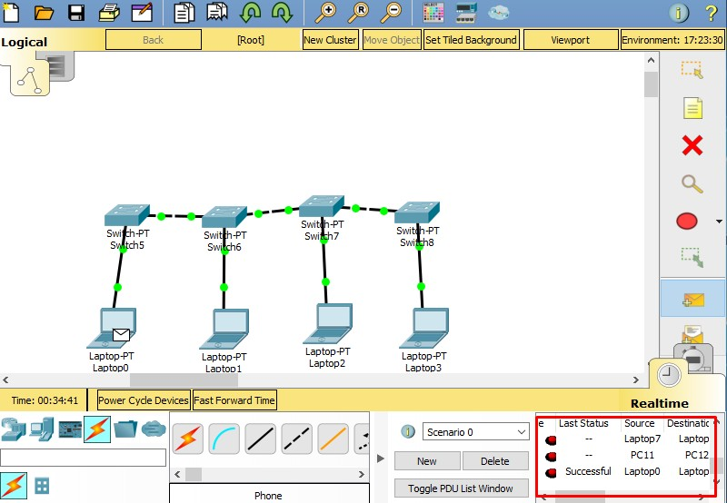

**Figure .54: showing the status of the PDU.**

1. **Moreover, when you are in simulation mode of the cisco packet tracer you can see how a PDU is going and to where its going and what is its contents and father information about the PDU by clicking on PDU.**

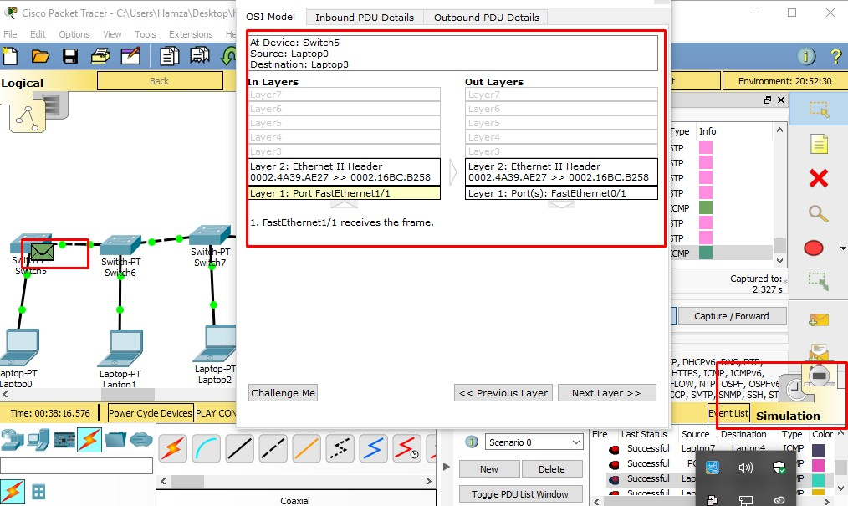

Figure 41: showing contents and information about the PDU

1. **Practice Tasks:**

**6.1 Task 1**

Construct a Mesh network topology which have four switches connected with 4 computers and

assign them proper IP addresses, subnet mask and default gateways, also show the status of

the PDU, by sending PDU from one PC to Another.

**6.2 Task 2**

Construct a star network topology which have one Hub connected with 4 computers and assign

them proper IP addresses, subnet mask and default gateways, also show the status of the PDU,

by sending PDU from one PC to Another.

**6.3 Task 3**

Construct a ring network topology which have five switches connected with 5 computers and

assign them proper IP addresses, subnet mask and default gateways, also show the status of

the PDU, by sending PDU from one PC to Another.

**6.4 Task 4**

Construct a tree network topology which have three switches connected with 3 computers and

assign them proper IP addresses, subnet mask and default gateways, also show the status of

the PDU, by sending PDU from one PC to Another.

**Configuring IP Address on a Router**

enable

configure terminal

interface g0/0

ip address 192.168.1.1 255.255.255.0

no shutdown

exit

exit

**Configuring an IP Address on a Switch (For Layer 3 Switches or VLANs)**

enable

configure terminal

interface vlan 1

ip address 192.168.1.2 255.255.255.0

no shutdown

exit

exit